

**UNIVERSITY OF PETROLEUM AND ENERGY STUDIES**

**School of Computer** **Science**

**2020-21**

**GRAPHICS AND ANIMATION TOOLS LAB**

**Faculty: Dr. DURGANSH SHARMA**

**Assistant Professor**

**Department of Cybernetics.**

**School of Computer Science, UPES**

**Submitted By:**

**Name- Vaibhav Kansal**

**Roll no-R100217086**

**Batch-B3**

**Semester- 7**

**Course-B.tech. CSE-OSOS**

**Sap Id- 500061579**

**EXPERIMENT NO 6- Design of Hut using Blender**

**STEPS :-**

1. Open Blender workspace delete the existing cube and Click on the add option and add cylinder.

2. Then we will make some adjustments in the cylinder like radius and depth, we will set the depth and radius as 2m.

3. After making changes in the cylinder we will select the upper face of cylinder and then extrude it.

4. After the above step we will shape that extruded region like the upper part of the hut using scale option.

5. For creating a door we are going to select any front face of the cylinder and then delete it using X key.

6. To give hut a realistic effect we will add the texture on it by going in the shading section and selecting the image that we will download from the internet. Then drag it and connect it to the base color of the object properties.

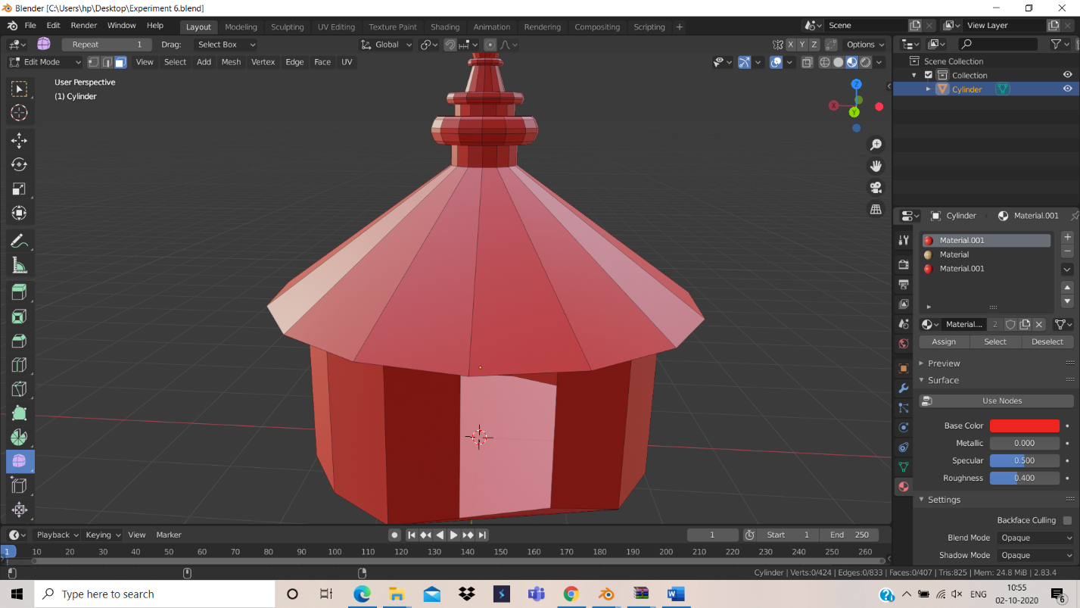

**Link of google drive**

https://drive.google.com/drive/folders/1y1__oHShVZMMjopCbs3nHGOvnXCm_2U9?usp=sharing